Additional Record of Pelagic Tunicate Pyrosoma atlanticum Péron, 1804 from Mersin Bay, Northeastern Mediterranean
Ali Uyan^{*1}, Necdet Uyğur ², Cemal Turan ¹, Servet Ahmet Doğdu ^{1,2}
¹ Iskenderun Technical University, Faculty of Marine Sciences and Technology, Molecular Ecology and Fisheries Genetics Laboratory, 31220, Iskenderun, Hatay, Türkiye.
² Iskenderun Technical University, Maritime Technology Vocational School of Higher Education, Underwater Technologies, 31200 Iskenderun, Hatay, Türkiye.

Corresponding Author: ali.uyan@yahoo.com
Abstract
Pyrosomes, belonging to the Pyrosomatidae family, are pelagic, colonial tunicates composed of thousands of zooids within a common, gelatinous tunic. They are known for their long-lived bioluminescence and occasional large-scale blooms. Pyrosoma atlanticum Peron, 1804 the only representative of pyrosomes in the Mediterranean, was reported from Mersin Bay, Northeastern Mediterranean (Türkiye). On 9 February 2025, a single colony of P. atlanticum was observed during a scuba dive at a depth of 12 m in Mersin Bay. The present study reports an additional record for the pelagic tunicate P. atlanticum in the northeastern Mediterranean.
Keywords: Pyrosomes, Pyrosoma atlanticum, additional record, Mersin coast, Türkiye
Introduction
Pyrosomes, whose etymology is based on the Greek words πύρο (fire) and σῶμα (body) because of their bioluminescent glow, are gelatinous zooplankton belonging to the class Thaliacea, found in temperate waters worldwide (Carvalho and Bonecker, 2008). They are pelagic tunicates composed of tens of thousands of zooids, covered by a common gelatinous tunic, and organized into colonies, and are also well-known for their long-lived bioluminescence and occasional massive blooms (Madin and Deibel, 1998; Kuo et al., 2015). As holoplanktonic grazers, pyrosomes primarily consume phytoplankton of various types and sizes (Drits et al., 1992; Perissinotto et al., 2007; Decima et al., 2019). Pyrosomes also play a significant role in transferring carbon and energy to deep-sea waters through the production of extensive faecal pellets (Drits et al., 1992) and carcass sedimentation (Lebrato and Jones, 2009) owing to their high filtration capability (Henschke et al., 2019). They are preyed upon by sea lions, sharks, fish, arthropods, cnidarians, turtles, and seabirds (Lebrato and Jones, 2009; Archer et al., 2018; Brodeur et al., 2021). These features and their roles in food chains have made them an important part of the marine ecosystem and carbon cycle (Lebrato and Jones, 2009; Henschke et al., 2019).
The Pyrosomatidae family includes the Pyrosoma genus, which consists of four accepted species: Pyrosoma aherniosum Seeliger, 1895, Pyrosoma atlanticum Péron, 1804, Pyrosoma godeauxi van Soest, 1981, and Pyrosoma ovatum Neumann, 1909 (van der Land and van Soest, 2001; WoRMS, 2025). Of these pelagic tunicate species, Pyrosoma atlanticum is the most widely distributed species, with a global range extending from 50°N to 50°S (van Soest, 1981). The species has long been of interest in the northeastern Pacific Ocean, especially in the Northern California Current zone (Lavaniegos and Ohman, 2007). Recently, P. atlanticum blooms have been observed outside of its natural habitat in the North Pacific Ocean, likely because of the effects of large marine heat waves (Henschke et al., 2019; Miller et al., 2019). The distribution pattern is closely connected to the biological features of P. atlanticum. Its short life cycle, fast growth, and efficient filtration rates allow its population to grow rapidly in favourable conditions (Alldredge and Madin, 1982), sometimes resulting in the formation of massive swarms (Angel, 1989; Drits et al., 1992).
Like all other gelatinous zooplankton, hydrodynamic features such as currents, whirlpools, and fronts significantly influence the transport, concentration, and abundance of P. atlanticum (Graham et al., 2001; Guerrero et al., 2016; Bellido et al., 2020). Physical and biological gradients in the water column determine the diel vertical migration of these organisms, either limiting their movement or leading to an uneven distribution, increasing their abundance (Gibbons et al., 1999; McManus et al., 2003; Nogueira Junior et al., 2015). The diel vertical migration of P. atlanticum ranges from 650 m to 2500 m (Andersen et al., 1992; Stenvers et al., 2021) in the Atlantic Ocean and 515 m to 900 m (Andersen et al., 1992; Sardou et al., 1996) in the Mediterranean, resulting in the species being considered highly migratory (Roe et al., 1987). The daily vertical migration depth of the species increases in direct proportion to the total length of the colonies, in other words, large colonies can reach higher depths than small ones (Granata et al., 2020). One hypothesis suggests that P. atlanticum blooms form in highly productive waters with temperatures below 18°C (Lilly et al., 2023).
P. atlanticum is the sole representative of the family Pyrosomatidae in the Mediterranean and so far the species has been observed from several localities in the basin: Israeli coasts (eastern Mediterranean) (Galil and Goren, 1994), Villefranche-sur-Mer coasts (Ligurian Sea) (Sardou et al., 1996), southeastern Crete (Aegean Sea), and off southwestern and northeastern Cyprus (Weikert and Godeaux, 2008), Gökçeada coast (northern Aegean Sea) and Iskenderun Bay (northeastern Mediterranean) (Gönülal and Dalyan, 2017), Ligurian submarine canyons (northwestern Mediterranean) (Granata et al., 2020), Girona coasts (western Mediterranean) (Pastor-Prieto et al., 2022), and Karpathos and Rhodes coasts (southern Aegean Sea) (Brissimi et al., 2024).
Based on the previous observations, the northeastern Mediterranean presence of the species was first recorded from Iskenderun Bay. Therefore, the present study contributes to the known distribution of P. atlanticum in this region by providing a new locality from Mersin Bay, Türkiye.
Material and Methods
A single colony of P. atlanticum was spotted during a scuba dive at a depth of 12 m in Mersin Bay (36.457000, 34.142056), northeastern Mediterranean (Türkiye), on February 9, 2025. The specimen was initially recorded underwater and carefully brought ashore. P. atlanticum was photographed after its total length was measured to the nearest 0.01 mm using a digital calliper, and its weight was recorded. The specimen was preserved in 95% ethanol and transported to the laboratory. The morphological characteristics of P. atlanticum were described according to Godeaux et al. (1998).
Result and Discussion
The pelagic tunicate P. atlanticum was recorded as 154 mm in total length and 86 g in live weight. The identification of the species was confirmed based on the following diagnostic features: the zooids forming the colony form a rigid tube which may be pale pink, yellowish or bluish. One end of the tube is narrower and closed; the other end is open and has a distinct diaphragm. The outer surface or test is gelatinous and pitted with blunt, backwards-directed projections (Figure 1 and 2). The morphological descriptions emphasized by Godeaux et al. (1998) reflected the general morphological features and colours of the captured P. atlanticum.
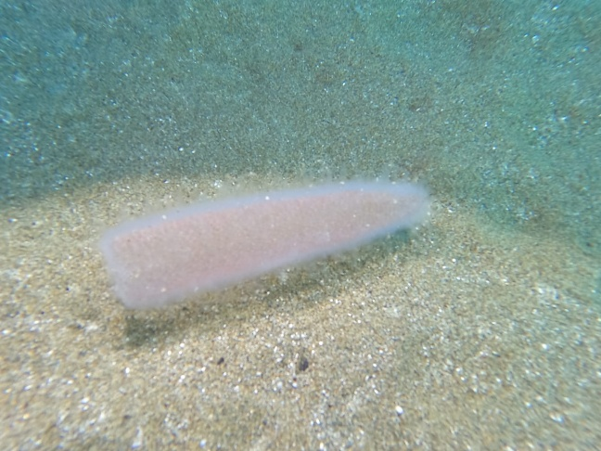
Figure 1. Underwater display of the single Pyrosoma atlanticum colony observed in Mersin Bay, northeastern Mediterranean (Türkiye).
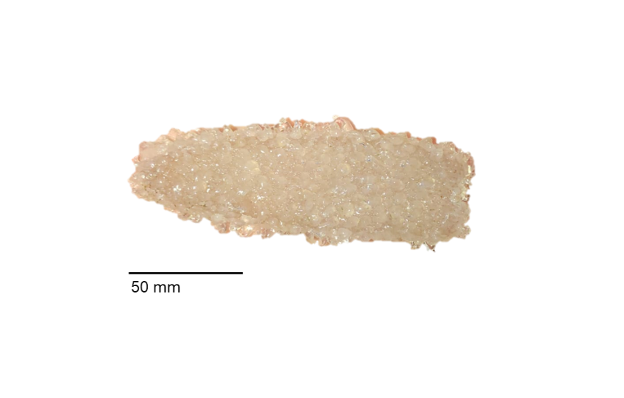
Figure 2. Macroscopic display of Pyrosoma atlanticum obtained from Mersin Bay.
In the Mediterranean Sea, research on P. atlanticum has been scarce, apart from comprehensive studies focusing on the French and Spanish coasts of the western basin by Sardou et al. (1996), Granata et al. (2020), and Pastor-Prieto et al. (2022). The species’ presence in the eastern basin was based only on localization-uncertain records reported from Israel (Galil and Goren, 1994) and Cyprus (Weikert and Godeaux, 2008). However, the recent confirmation of P. atlanticum’s presence in the eastern Mediterranean was recorded by Gönülal and Dalyan (2017) from both Iskenderun Bay (northeastern Mediterranean Sea) and Gökçeada coasts (northern Aegean Sea), as well as by Brissimi et al. (2024) from Karpathos and Rhodes coasts (southern Aegean Sea). This study contributes to the previously confirmed eastern Mediterranean distributions of P. atlanticum by including that of Mersin Bay, northeastern Mediterranean.
The temporal and spatial irregularity and the scarcity of research on P. atlanticum in the eastern Mediterranean compared to the Western Mediterranean may be due to several main reasons, including sampling bias, limited funding due to low scientific interest, difficulties in identifying gelatinous zooplankton taxa, and the inability to keep colonies alive for more than a few hours in the laboratory (Brissimi et al., 2024). However, external to the Mediterranean basin, such as in the Northern California Current, P. atlanticum blooms are more frequent and regularly observed in samples. This indicates that the species might be less rare than once believed and that its presence in the Mediterranean Basin could be significantly underestimated (Lavaniegos and Ohman, 2007; Brodeur et al., 2018).
In conclusion, the present study reports a new locality record for pelagic tunicate P. atlanticum in the northeastern Mediterranean and provides a brief review of its distribution across the entire Mediterranean Basin. Research on the seasonal abundance and diel vertical migration of P. atlanticum colonies is limited, despite their potential significance in the marine food web in the Mediterranean. Therefore, further studies are needed to explore the biology, ecology, and broader influences of these gelatinous organisms.
Conflict of Interest
The authors declare that for this article they have no actual, potential or perceived conflict of interest.
Author Contributions
A.U., C.T. and S.A.D. performed all the experiments and drafted the main manuscript text. N.U and S.A.D. obtained a specimen. The authors reviewed and approved the final version of the manuscript.
Ethical Approval Statements
No ethics committee permissions are required for this study.
Data Availability
The data used in the present study are available upon request from the corresponding author.
References
Alldredge, A. L., Madin, L. P. (1982). Pelagic tunicates: unique herbivores in the marine plankton. Bioscience, 32(8), 655-663.
Andersen, V., Sardou, J., Nival, P. (1992). The diel migrations and vertical distributions of zooplankton and micronekton in the Northwestern Mediterranean Sea. 2. Siphonophores, hydromedusae and pyrosomids. Journal of Plankton Research, 14(8), 1155-1169.
Angel, M. V. (1989). Vertical profiles of pelagic communities in the vicinity of the Azores Front and their implications to deep ocean ecology. Progress in Oceanography, 22(1), 1-46.
Archer, S. K., Kahn, A. S., Leys, S. P., Norgard, T., Girard, F., Du Preez, C., Dunham, A. (2018). Pyrosome consumption by benthic organisms during blooms in the northeast Pacific and Gulf of Mexico. Ecology, 99, 981-984.
Bellido, J. J., Baez, J. C., Souviron-Priego, L., Ferri-Yanez, F., Salas, C., López, J. A., Real, R. (2020). Atmospheric indices allow anticipating the incidence of jellyfish coastal swarms. Mediterranean Marine Science, 21(2), 289-297.
Brissimi, C., Pantelidou, M., Kallianiotis, A. A., Vidoris, P., Antoniadou, C., Anastasiadou, C. (2024). Notes on Pyrosoma atlanticum Péron, 1804 with a revision of the deep-sea taxon in the Mediterranean basin. Oceanography Fisheries Open Access Journal, 17(3), 555970.
Brodeur, R. D., Perry, I., Boldt, J., Flostrand, L., Galbraith, M., King, J., Murphy, J., Sakuma, K., Thompson, A. (2018). An unusual gelatinous plankton event in the NE Pacific: the great pyrosome bloom of 2017. PICES Press, 26(1), 22-27.
Brodeur, R. D., Buckley, T. W., Lang, G. M., Draper, D. L., Buchanan, J. C., Hibpshman, R. E. (2021). Demersal fish predators of gelatinous zooplankton in the Northeast Pacific Ocean. Marine Ecology Progress Series, 658, 89-104.
Carvalho, P. F., Bonecker, S. L. C. (2008). Tunicata, Thaliacea, Pyrosomatidae, Pyrosomella verticillata (Neumann, 1909): first record from the Southwest Atlantic Ocean. Check List, 4(3), 272-274.
Decima, M., Stukel, M. R., López‐López, L., Landry, M. R. (2019). The unique ecological role of pyrosomes in the Eastern Tropical Pacific. Limnology and Oceanography, 64(2), 728-743.
Drits, A. V., Arashkevich, E. G., Semenova, T. N. (1992). Pyrosoma atlanticum (Tunicata, Thaliacea): grazing impact on phytoplankton standing stock and role in organic carbon flux. Journal of Plankton Research, 14(6), 799-809.
Galil, B. S., Goren, M. (1994). The deep sea Levantine fauna. New records and rare occurrences. Senckenbergiana Maritima, 25, 41-52.
Gibbons, M. J., Gugushe, N., Boyd, A. J., Shannon, L. J., Mitchell-Innes, B. A. (1999). Changes in the composition of the non-copepod zooplankton assemblage in St Helena Bay (southern Benguela ecosystem) during a six day drogue study. Marine Ecology Progress Series, 180, 111-120.
Godeaux, J., Bone, Q., Braconnot, J. C. (1998). Anatomy of Thaliacea. In The Biology of Pelagic Tunicates (pp. 1-24). Oxford Academic.
Gönülal, O., Dalyan, C. (2017). Bathymetric distribution of macroinvertebrates in the Northeastern Levantine Sea and the Northeastern Aegean Sea based on bottom-trawl surveys. Oceanological and Hydrobiological Studies, 46(4), 405-413.
Graham, W. M., Pagès, F., Hamner, W. M. (2001). A physical context for gelatinous zooplankton aggregations: a review. Hydrobiologia, 451, 199-212.
Granata, A., Bergamasco, A., Battaglia, P., Milisenda, G., Pansera, M., Bonanzinga, V., Arena, G., Andaloro, F., Giacobbe, S., Greco, S., Guglielmo, R., Spanò N., Zagami, G. Guglielmo, L. (2020). Vertical distribution and diel migration of zooplankton and micronekton in Polcevera submarine canyon of the Ligurian mesopelagic zone (NW Mediterranean Sea). Progress in Oceanography, 183, 102298.
Guerrero, E., Marrodán, A., Sabatés, A., Orejas, C., Gili, J. M. (2016). High spatial heterogeneity of two planktonic cnidarian species related to the variability of a shelf-slope front at short time scales. Scientia Marina, 80(4), 487-497.
Henschke, N., Pakhomov, E. A., Kwong, L. E., Everett, J. D., Laiolo, L., Coghlan, A. R., Suthers, I. M. (2019). Large vertical migrations of Pyrosoma atlanticum play an important role in active carbon transport. Journal of Geophysical Research: Biogeosciences, 124(5), 1056-1070.
Kuo, C. Y., Fan, T. Y., Li, H. H., Lin, C. W., Liu, L. L., Kuo, F. W. (2015). An unusual bloom of the tunicate, Pyrosoma atlanticum, in southern Taiwan. Bulletin of Marine Science, 91, 363-364.
Lavaniegos, B. E., Ohman, M. D. (2007). Coherence of long-term variations of zooplankton in two sectors of the California Current System. Progress in Oceanography, 75(1), 42-69.
Lebrato, M., Jones, D. O. B. (2009). Mass deposition event of Pyrosoma atlanticum carcasses off Ivory Coast (West Africa). Limnology and Oceanography, 54(4), 1197-1209.
Lilly, L. E., Suthers, I. M., Everett, J. D., Richardson, A. J. (2023). A global review of pyrosomes: Shedding light on the ocean's elusive gelatinous “fire‐bodies”. Limnology and Oceanography Letters, 8(6), 812-829.
Madin, L. P., Deibel, D. (1998). Feeding and energetics of Thaliacea. In The biology of pelagic tunicates (pp. 81-103). Oxford University Press.
McManus, M. A., Alldredge, A. L., Barnard, A. H., Boss, E., Case, J. F., Cowles, T. J., Donaghay, P. L., Eisner, L. B., Gifford, D. J., Greenlaw, C. F., Herren, C. M., Holliday, D. V., Johnson, D., MacIntyre, S., McGehee, D. M., Osborn, T. R., Perry, M. J., Pieper, R. E., Rines, J. E. B., Smith, D. C., Sullivan, J. M., Talbot, M. K., Twardowski, M. S., Weidemann, A., Zaneveld, J. R. (2003). Characteristics, distribution and persistence of thin layers over a 48 hour period. Marine Ecology Progress Series, 261, 1-19.
Miller, R. R., Santora, J. A., Auth, T. D., Sakuma, K. M., Wells, B. K., Field, J. C., Brodeur, R. D. (2019). Distribution of pelagic thaliaceans, Thetys vagina and Pyrosoma atlanticum, during a period of mass occurrence within the California Current. CalCOFI Reports, 60, 94-108.
Nogueira Junior, M., Brandini, F. P., Codina, J. C. U. (2015). Diel vertical dynamics of gelatinous zooplankton (Cnidaria, Ctenophora and Thaliacea) in a subtropical stratified ecosystem (south Brazilian bight). PLoS One, 10, e0144161.
Pastor-Prieto, M., Sabatés, A., Raya, V., Canepa, A., Parraguez, T. I., Gili, J. M. (2022). The role of oceanographic conditions and colony size in shaping the spatial structure of Pyrosoma atlanticum in the NW Mediterranean Sea. Journal of Plankton Research, 44(6), 984-999.
Perissinotto, R., Mayzaud, P., Nichols, P. D., Labat, J. P. (2007). Grazing by Pyrosoma atlanticum (Tunicata, Thaliacea) in the south Indian ocean. Marine Ecology Progress Series, 330, 1-11.
Roe, H. S. J., Badcock, J., Billett, D. S. M., Chidgey, K. C., Domanski, P. A., Ellis, C. J., Fasham, M. J. R., Gooday, A. J., Hargreaves, P. M. D., Huggett, Q. J., James, P. T., Kirkpatrick, P. A., Lampitt, R. S., Merrett, N. R., Muirhead, A., Pugh, P. R., Rice, A. L., Russell, R. A., Thurston, M. H., Tyler, P. A. (1987). Great Meteor East: a biological characterisation. Institute of Oceanographic Sciences Deacon Laboratory.
Sardou, J., Etienne, M., Andersen, V. (1996). Seasonal abundance and vertical distributions of macroplankton and micronekton in the Northwestern Mediterranean Sea. Oceanologica Acta, 19(6), 645-656.
Stenvers, V. I., Hauss, H., Osborn, K. J., Neitzel, P., Merten, V., Scheer, S., Robison, B. H., Freitas, R., Hoving, H. J. T. (2021). Distribution, associations and role in the biological carbon pump of Pyrosoma atlanticum (Tunicata, Thaliacea) off Cabo Verde, NE Atlantic. Scientific Reports, 11(1), 9231.
van der Land, J., van Soest, R. W. M. (2001). Thaliacea. In European Register of Marine Species: A Check-list of the Marine Species in Europe and A Bibliography of Guides to Their Identification (pp. 355-356). Collection Patrimoines Naturels.
van Soest, R. W. M. (1981). A monograph of the order Pyrosomatida (Tunicata, Thaliacea). Journal of Plankton Research, 3(4), 603-631.
Weikert, H., Godeaux, J. E. (2008). Thaliacean distribution and abundance in the northern part of the Levantine Sea (Crete and Cyprus) during the eastern Mediterranean climatic transient, and a comparison with the western Mediterranean basin. Helgoland Marine Research, 62, 377-387.
WoRMS (2025). Pyrosoma Péron, 1804. World Register of Marine Species. Available at: https://www.marinespecies.org/aphia.php?p=taxdetails&id=137224 (10.05.2025).

